Phase 1 — Ideation Phase
Empathy Map Canvas
Field | Value
Date | 31 January 2026
Team ID | SWTID-2026-1543
Project Name | Virtual Agent–Driven SLA Breach Awareness & Justification System
Maximum Marks | 2 Marks

Target User Persona: ITIL Service Desk Agent / Assigned Support Engineer — a frontline technical support agent managing active incidents under strict corporate Service Level Agreements (SLAs).
Methodology: The team conducted structured interviews and process-shadowing sessions with Service Desk agents and their managers, then synthesized recurring statements, behaviors, and emotional cues into the six quadrants of the Empathy Map Canvas below. This ensured the resulting problem statement was grounded in real user experience rather than assumption.
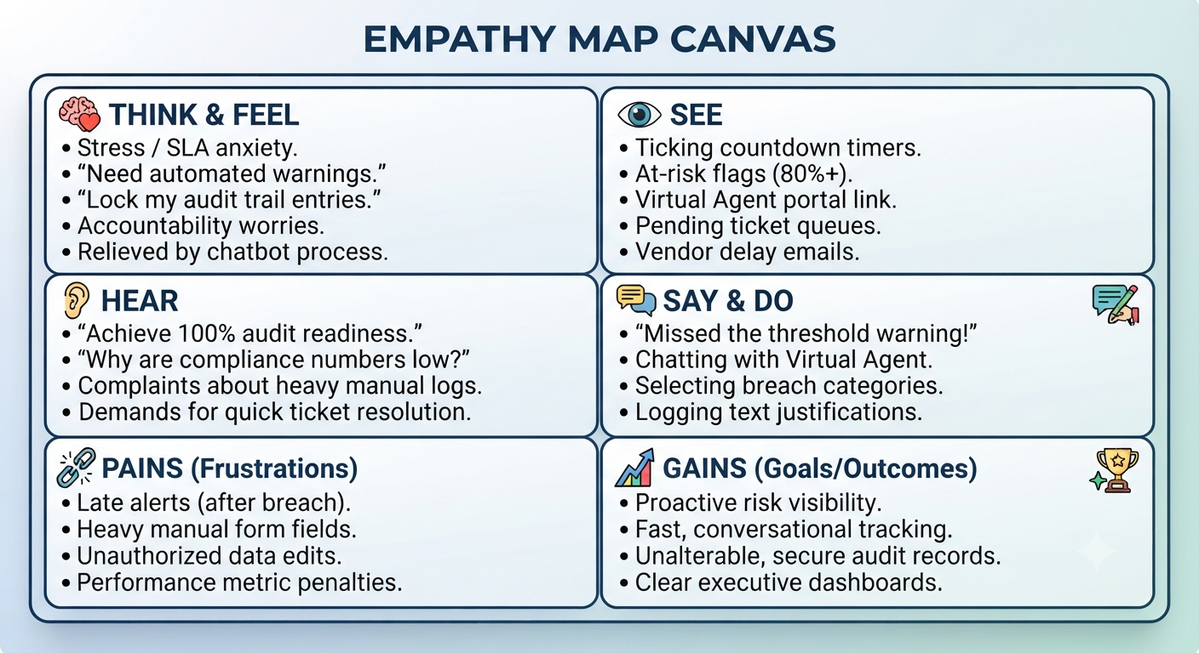
Figure 1.1 — Empathy Map Canvas: Virtual Agent-Driven SLA Breach Awareness & Justification System
Quadrant | Summary
Think & Feel | Stress / SLA anxiety; "Need automated warnings"; "Lock my audit trail entries"; accountability worries; relieved by the chatbot process
Hear | "Achieve 100% audit readiness"; "Why are compliance numbers low?"; complaints about heavy manual logs; demands for quick ticket resolution
See | Ticking countdown timers; at-risk flags (80%+); Virtual Agent portal link; pending ticket queues; vendor delay emails
Say & Do | "Missed the threshold warning!"; chatting with the Virtual Agent; selecting breach categories; logging text justifications
Pains | Late alerts (after breach); heavy manual form fields; unauthorized data edits; performance metric penalties
Gains | Proactive risk visibility; fast conversational tracking; unalterable, secure audit records; clear executive dashboards

Persona Snapshot
Attribute | Description
Role | ITIL Service Desk Agent (Level 1/2 Support), also representative of Service Desk Managers and Compliance Auditors as secondary stakeholders
Daily Context | Manages 10–20 concurrent incidents/tasks, each bound by a contractual or internal SLA; works within the standard ServiceNow Agent Workspace
Primary Goal | Resolve incidents within SLA while maintaining an accurate, defensible audit trail
Biggest Frustration | Discovering an SLA has already breached with no prior warning, then having to manually reconstruct what happened for reporting
Definition of Success | Zero surprise breaches; every breach that does occur is instantly, clearly justified and logged

Key Insights Derived
- Agents want a nudge, not a scold — the notification needs to arrive while corrective action is still possible, not as a post-mortem.
- Manual logging is the single biggest source of friction; anything that reduces typing/clicking during an already-stressful moment will be adopted more readily.
- Trust in the audit trail matters as much as the trail itself — agents specifically asked for entries that cannot later be edited or disputed.
- Managers and auditors need a summarized, not raw, view — they don't want to sift through individual tickets to understand SLA health.

